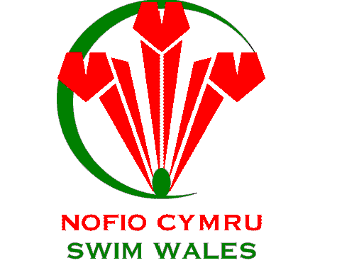

Regional Academy Swimming Coaches Opportunities – Level 1 or 2

Organisation – Swim Wales Regional Para-Swimming Academies
Locations:
- South Wales Titans (Bridgend, Cardiff and Vale of Glamorgan)
- Gwent Spartans (Torfaen, Monmouthshire and Newport)
- North Wales Trojans (Wrexham, Flintshire and Denbighshire)
Salary – Voluntary

Swim Wales Regional Para-Swimming Academies are continually looking for enthusiastic coaches who believe they could add to a competitive driven programme aimed at coaching and training Para-Swimmers to a national level. If you are interested please contact Swim Wales National Para-Swimming Manager, Huw Griffiths at huw.griffiths@welshasa.co.uk

